Welcome Club – Perseverance 2 – Problem Solving & Dealing with Fear
Staff contact: Megan 916-937-1365
Materials
General | Masks, Clip board, snack, water, name tag, hand sanitizer, pens, pencils, markers, check-in sheet
Mystery box | 6 boxes per classroom, top ramen, slime, oatmeal (chocolate chips, Rasins, carrots, pees..) teddy bear, soba noodles, tapioca or boba, hairbrush, folding table
Secret Maze | masking tape/paper plate/paper, drop cloth/tarp, ‘map’ of maze
Building game | Spaghetti, playdough, cardboard
Homework | Homework bin, pencils, pen

Objective
Students will be able to be aware of possible fears and ways to solve problems.

Welcome Students – 10 minutes
*Boys and girls will check-in at separate classrooms.

- 1 Coach instructs students to line up outside and takes attendance. Be prepared to add new students to the roster. Ask the new student their first name, last name, grade and teacher’s name (if they do not know their teacher’s name that’s ok but the first 3 are a must).
- Remaining Coaches unstack chairs and prep group tables. We will be passing out snacks as students walk in, direct them to their table, etc. Once snacks have been passed out, please put the remaining snacks away for the day. (“Extra” snacks tend to be a distraction to students when left out and available.)
Prompt Questions: Use the questions below to start conversation.
Do you remember what Perseverance means? (keep trying even when it is hard) What did you do that was hard this week? What was your school goal from last week? (Refer to last week’s goals) What did you do to try to work on your goal? How can we practice your goal today?
________________________________________________________________________________________________
Welcome: Lead Coach
1st “Welcome to Welcome Club! Today we have a really fun day planned for you! Who remembers what we learned last week? (Listening, and maybe repeat the definition of Equity) Who remembers what Equity means? (See definition above). Today we are going to talk about Problem-solving. Who remembers what perseverance means? Yes! Perseverance means “Keep going even when it is hard.” What are some ways that you can persevere at school? That is a good example. You had a problem (restate) and you solved it by doing (action)
2nd Now we are going to play a game but first we need to go over our Welcome Club Agreements! (Use “Four Squares of Treatment” to go over how we treat each other, etc. and transition into next section)

3rd It is time to clean up our snack! First table with clean desks and quiet arms get to go outside first!
Materials: name tags, sign in sheet, pens

Activity: Secret maze – 20 minutes
Description of activity.
Lead Coach: explains how to play and uses coaches to demonstrate the game.
- A grid will be set up with the starting square clearly marked.
- Table coach will have a paper with a matching grid set up. (only the table coach can look at this paper)
- The 1st student then approaches the grid and steps on the first square.
- The table coach will say safe or out based on the safe path on their paper. Safe=student continues to the next square. Out=Student must go to the back of the line .
- If the square is safe then the student picks a second square to step on. The square the student moves to must be touching the current square the student is standing on. Repeat step 4. The second student then steps on the square the 1st student just left. Repeat until first student is OUT
- When the first student is OUT the second student becomes the leader.

Table Coach: Act as ‘Team Captain’ Encouraging students to remember the places they cannot step and helping their team.
- Table coach has the answer key and will direct the students to make it through the maze.

Bellow are pictures of an example answer key and a student playing the game.
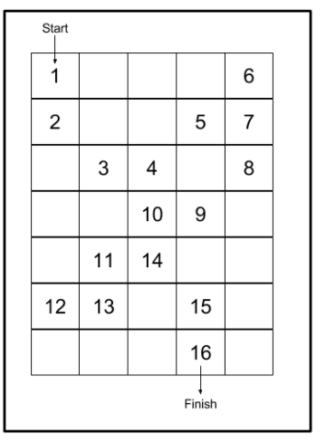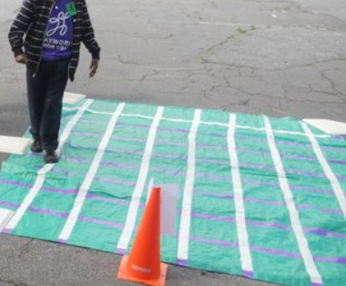
Video of how to play
Materials: masking tape/paper plate/paper, drop cloth, ‘map’ of maze

Craft/Activity: What is in the box? – 20 minutes
*****Students are going to practice dealing with fear by touching mystery items ****

Boy’s and girl’s room join together for this activity. Coordinate timing with other room.

Lead Coach: explains how to do the activity.
- 6 boxes are set out. Each box contains a mystery item.
-One coach steps out from the previous activity to set up the boxes. The boxes should be placed on desks or picnic tables outside. They should be visible to each other but not next to each other.
- Each student with their table group is to reach their hand into the box and feel the item. (No looking)
-only one table group should be at any given box.
-TABLE COACHES: have students guess what they think they are touching.
- After all the students have touched the items. Have a few students guess what is inside the box.
- to the whole group: What do you think is in box number 1? A few students guess.
- Show the students what was in the box..

Co-Coach: join in and make sure your table understands how to play.
- Encourage the student if they are afraid to touch
- Participate in the exercise.

Discussion Questions: lead by lead coaches of respective rooms
- What item was the most surprising to you?
- Did you ever feel nervous when touching the things in the box?
- How did you get the bravery to touch the items in the box? What did you do? (take a breath, encouraged by a friend..)
- What is something you have faced that was scary? What did you do?
- How do you solve a problem that you are afraid of?

Materials: 6 boxes per classroom, top ramen, slime, oatmeal(chocolate chips, Rasins, carrots, pees..) teddy bear, soba noodles, tapioca or boba, hair brush,

Activity– Tower building 15 minutes
****Student will practice problem solving and team work to work together and build the tower****

LEAD Coach: Explain the activity
- Break students into pairs or have them work as a table
- Each group gets the same number of materials
- Give the student 5 minutes to try to build the largest tower

After everyone has finished move all the towers to 1 table and compare how big they are.

TABLE Coach: Guild the student in working together
- Facilitate teamwork
- Make sure all materials stay on the table
- Clean up table when finished

Materials: playdough, spaghetti, cardboard as base

Homework – 40 minutes
We will have printed out some worksheets for the students to work on. They are categorized by grade level and subject.
Students will focus on working on their homework for the day.
Transitioning to homework time can be difficult...all coaches should work together to ensure students are moving to desks, pulling out their homework, or picking a worksheet from the folder. Pick a couple of students to sit with and assist them during homework time.

- Coaches: Give any help to students when asked. Help them work out any struggles they might have

- Tutor tips:
    - Don’t give the answer to the students - help them work it out together.
  - MATH: use visuals to help them see the problem more clearly; Help them spot key words in word problems and how to solve it
  - LITERATURE/ENGLISH: help them sound out difficult words; if they are struggling and do not know the word, give them synonyms and give them a push to right direct

Clean Up– 5 minutes
Instruct students to pick up and throw away trash before they leave.
- Pick up and throw away trash.
- Sweep floor
- Clean up WC supplies

Please fill out this Survey: https://forms.office.com/r/r1kpc21QTh

